### Foundation

#### Species

* Coffea Arabica
  + More desirable cup profile
  + Higher _______
  + Less bitterness
  + Complex, more sweetness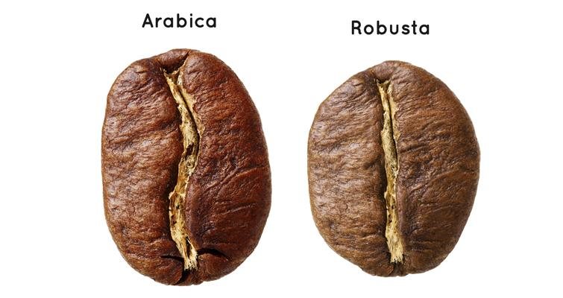
* Coffea Canephora (Robusta)
  + More bitterness
  + Higher ________ content
  + _______ body
  + More pest/disease ___________
  + Handles harsher growing conditions

#### Espresso Machine

**Pump pressure** for dispensing from groupheads is set to **7-11 Bar**

**Steam boiler** pressure is set above **1-1.5 Bar**

#### Grinder



(This model is doserless / “on demand”)



(This model has a dosing chamber)

#### 

#### Grinder Comparison

|  |  |
| --- | --- |
| **On Demand** | **Doser** |
| * Freshly ground * Flexibility with dose weight * Grinding time based/weight based | * Coffee ground all at once and then dosed * More areas for coffee buildup to happen |

#### Preparation for Using the Machine

* Checking Equipment and Tools
* Check boiler pressure
* Warming the group heads

#### Defining Espresso

Espresso is a **drink and method of preparation**. It is a beverage made by pumping clean, fresh water at **195-205°F (90.5-96.1° C) and 7-11 Bar** of pressure through _______ **grams** of compacted coffee with a particular grind size that it yields _______ **grams** of liquid in ________ seconds.

#### Elements Needed to Create Espresso

1. Coffee

* Freshly roasted, freshly ground

1. Machine

* Properly maintained espresso machine

1. Grinder

* Properly maintained and regularly cleaned

1. Water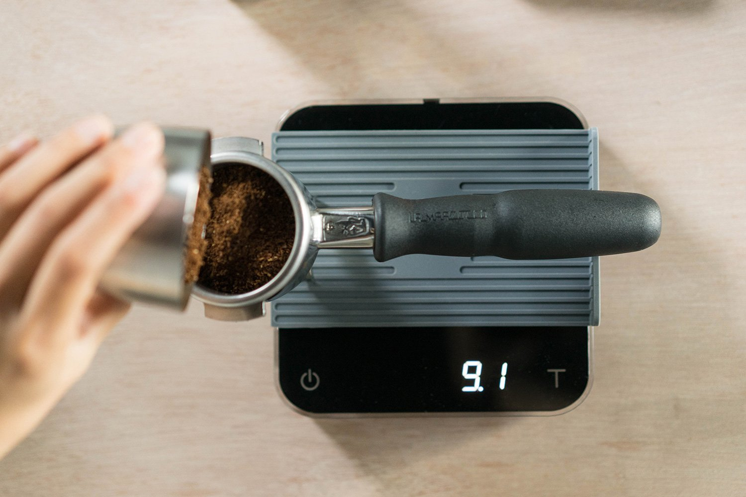

* Fresh, odorless, clean

1. Barista

* Skillful, knowledgeable

#### Variables

* Dose weight
* Grind size
* Beverage/water volume

There are others, but these are what we can adjust daily to achieve proper extraction.

#### Parameters

* _______ to _______ grams for double shot
* 20 to 30 ______________
* Brew Ratio of 1:______ to 1:______ grams in/grams out

#### Dosing

* Consistent ____________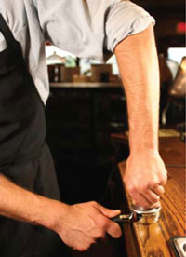
* Directly affects ____________
* ______________ → Longer/slower shot time
* Lower dose weight → Shorter/faster shot time

#### Grind Setting

* Finer - slower flow rate, longer time
* Coarser - faster flow rate, shorter time
* ___________ between adjustments to remove previous grind setting

#### Water Volume/Beverage Mass

* Higher mass/volume → Increased extraction, vice versa
* Affects Brew Ratio

#### Distribution

* Gently _________ portafilter to settle, if necessary
* Use your index finger to ____________
* ___________ distribution
* Minimize channeling

“**Channeling**”

Water flowing unevenly due to uneven density, or cracks/holes in the coffee basket.

#### 

#### 

#### Tamping

* Correct technique
  + Arm at _______° angle, straight wrist
  + __________ and even surface
* Consistency
  + Use the same pressure every time

#### Steps to Create Espresso

* Remove portafilter from grouphead and flush group
* Wipe basket clean and dry
* Dose and distribute desired weight
* Tamp consistently, level, and ergonomically
* Clean loose grounds from edges of portafilter
* Insert portafilter into grouphead and start immediately
* Observe flow and stop pump appropriately
* Serve or use to make espresso based-drink
* Remove portafilter and knockout spent grounds
* Wipe basket clean and flush group
* Return portafilter to grouphead to keep preheated

#### Extraction

* Under-extracted espresso tends to have an overly __________ flavor
* Over-extracted espresso tends to have an overly __________ flavor
* Properly extracted espresso should taste ______________ and __________

The Coffee Taster’s Flavor Wheel can be used to identify flavor/aroma characteristics. Body/texture descriptors will be different. (*E.g. Chewy, creamy, silky, thin, full, etc.)*

#### Roast Development

* Longer/more developed roasts tend to have more bitterness, less acidity
* Less developed/lighter roasts will be brighter, sweeter, more acidic

#### Coffee Freshness

* Oxygen
  + Causes ________, decreases freshness
* Moisture
  + Can cause bacterial or _________ growth
* Odors
  + Coffee will _______ odors and aromas
* Light/Heat
  + Causes oxidation rate to increase

Coffee should be ground freshly, and to order within ________________ of preparing, sooner for espresso preparation to maintain quality and consistency.

The optimal environment for storing coffee is airtight (**no oxygen**), **cool** (60-75℉), and **dry**.

#### Milk Steaming

The goal is to create steamed milk that is topped with **dense**, **velvety microfoam**, **moist/shiny texture,** and that moves with consistency of **melted marshmallow.**

This is accomplished by __________________ the milk in a precise and controlled manner.

**Desired temperature range is 131-149°F at the cup (55-65°C) with a maximum of 158°F at the pitcher (70°C).**

#### Milk Freshness

Discard milk that is:

* ___________________
* ___________________
* ___________________

Rotate milk as fresh milk is delivered. **Keep refrigerated at all times.**

#### Steps

* Purge steam wand
* Create ______________ and ___________.
* Stop aeration when warm
* Bring up to temp and stop
* _______ and _______ steam wand

#### Common Drink Recipes

**Latte**:

*Usually 1-2oz espresso, 8-10oz of steamed and textured milk poured on top*

**Cappuccino**:

*Usually 1-2oz espresso, 4-5oz steamed and textured milk poured on top*

**Americano**:

*1-2oz espresso, poured* ***on top*** *of cup filled with hot water.*

#### Role of Baristas

* Prepare beverages
* ____________________ information to guests
* Represent the _______________ and the work of other coffee professionals

#### 

#### Customer Service

#### Product

* Atmosphere
* __________ ____________________
* Service

#### Best Practices

* Soaking __________ __________
* Grinder hoppers
* Purging grinder, wiping away excess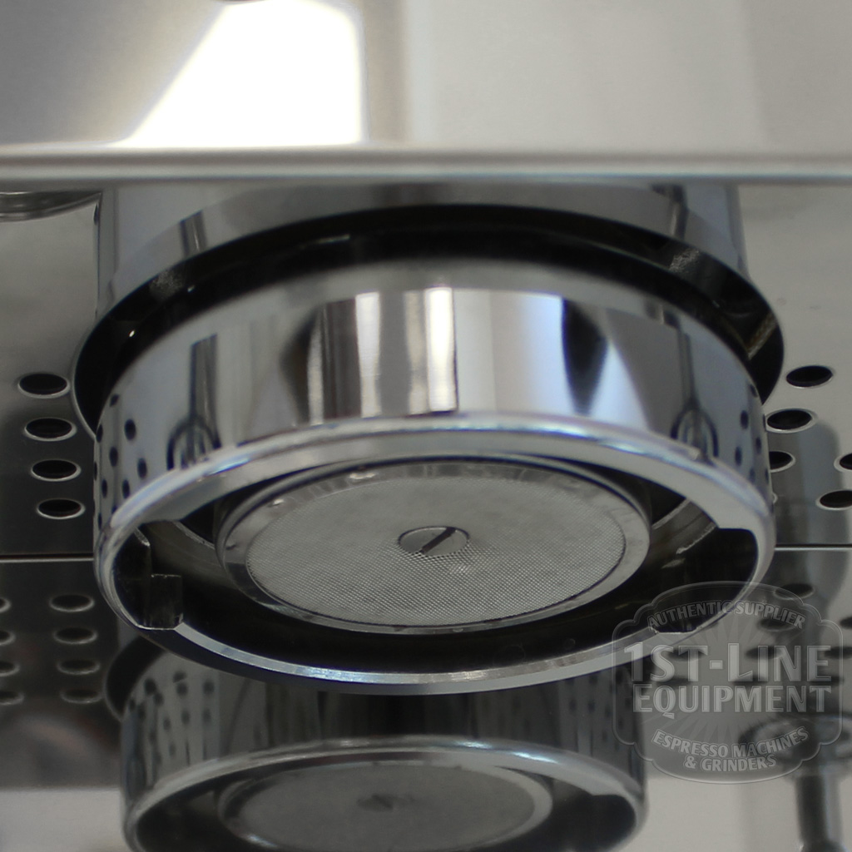
* ____________________ espresso machine
* Drip trays

Things you can expect if you don’t clean and maintain your equipment:

* ______, musty flavors
* Increased wear and tear on the equipment
* Shortened equipment lifespan (possible break of warranty)
* Bacterial or fungal growth

#### Health & Safety

* Wash hands
* Hold mugs by the __________ or ____________ (never the rim)
* Clean equipment ____________
* Use detergents or solutions specifically for coffee equipment (mild/unscented)

#### Maintenance

* Drinks will taste consistently _______________
* _______________ will last longer
* Conveys positive image to guests

#### Water Quality and Filtration

* Water hardness (mineral concentration) important to regulate
* Water with high hardness causes _________________
* Water should be free from taints (__________, sulphur)

#### Workspace

* Your workspace should be kept clean and _________________.
* Tidiness will increase hygiene level and convey quality to customers.
* Organization increases efficiency and minimizes ______.
* “Clean as you go”